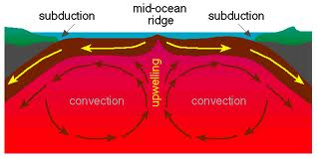
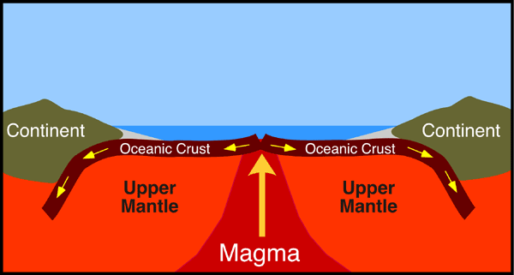
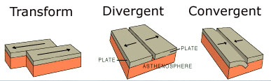
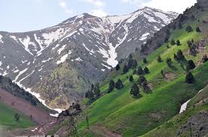

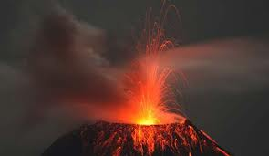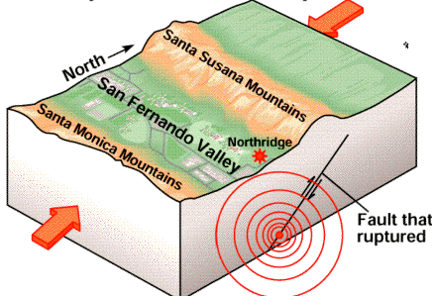

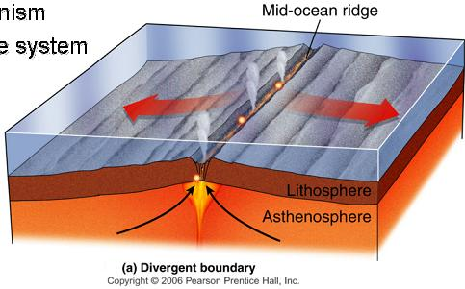

  - Plates of lithosphere move because of convection currents in the mantle.

  - One type of motion is produced byseafloor spreading.

  - • Plates interact at three types of plate boundaries: divergent, convergent and transform.

  - • Most of the Earth’s geologic activity takes place at plate boundaries.

  - • At a divergent boundary, volcanic activity produces a mid ocean ridge and small earthquakes.

  - • At a convergent boundary with at least one oceanic plate, an ocean trench, a chain of volcanoes develops and many earthquakes occur.

  - • At a convergent boundary where both plates are continental, mountain ranges grow and earthquakes are common.

  - • At a transform boundary, there is a transform fault and massive earthquakes occur but there are no volcanoes.

  - • Processes acting over long periods of time create Earth’s geographic features.

